Code Commit

New Repository created

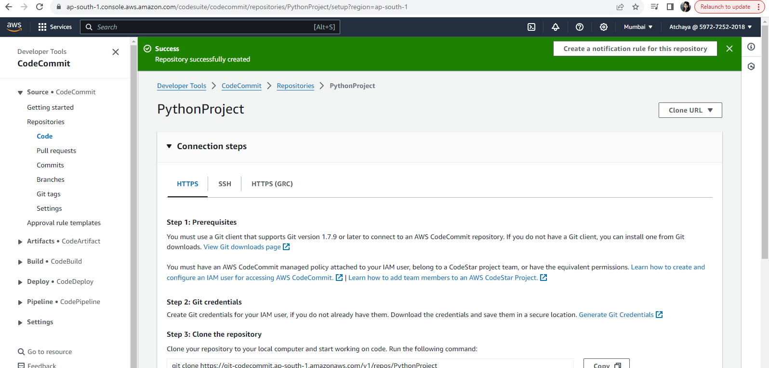

Files added to the repo

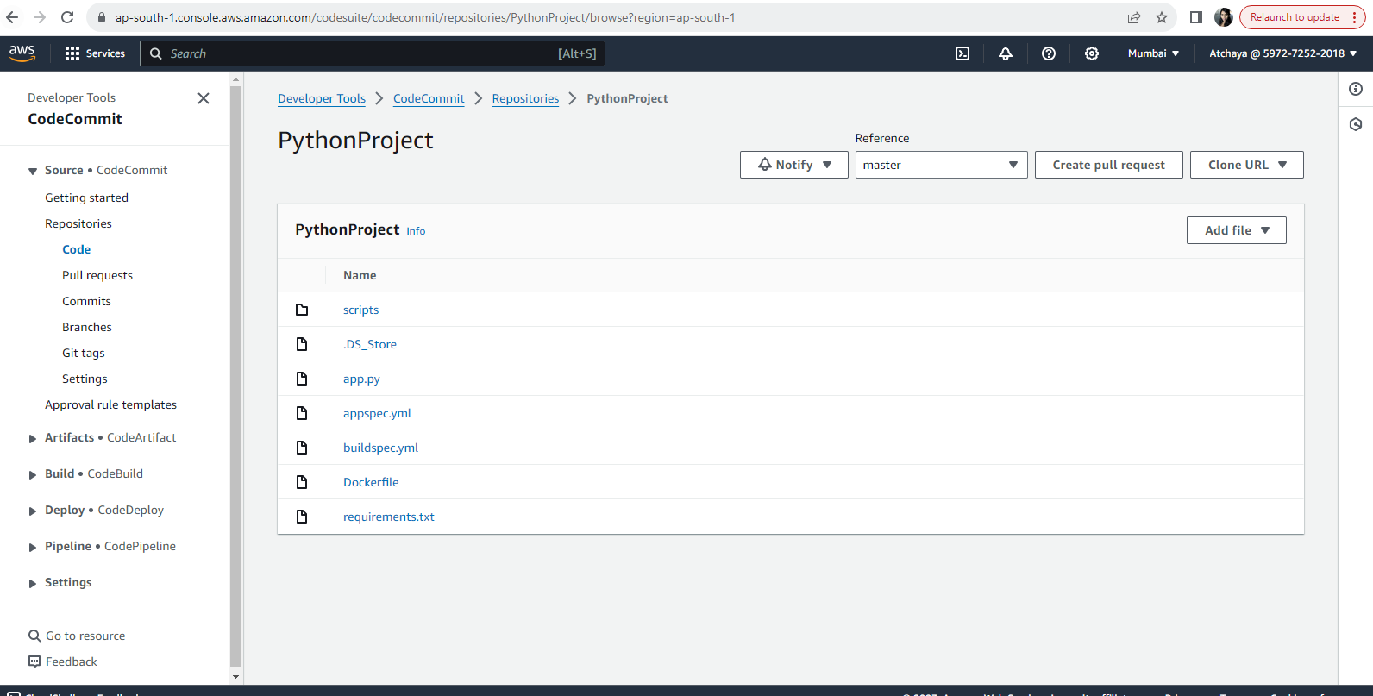

Code Build

New project created

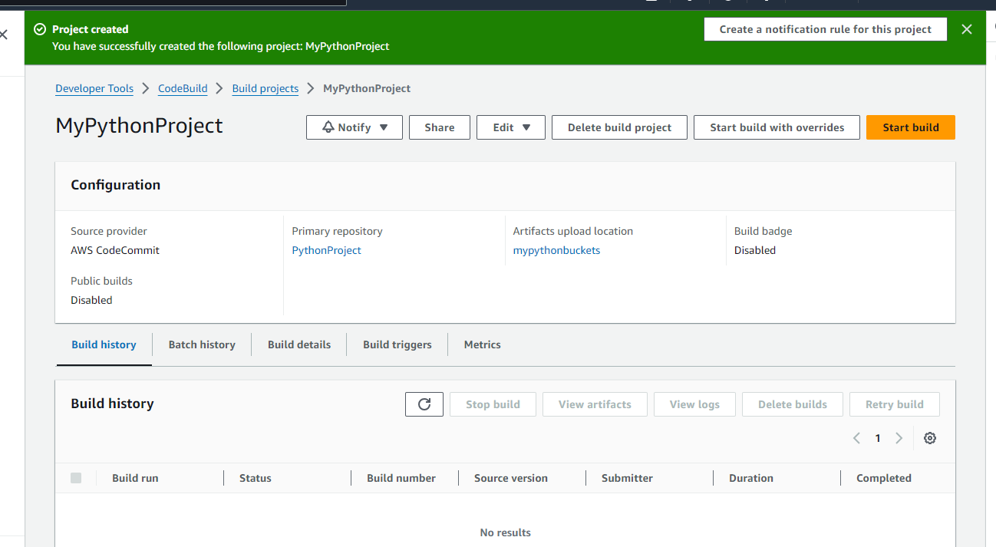

Started build

Build succeeded

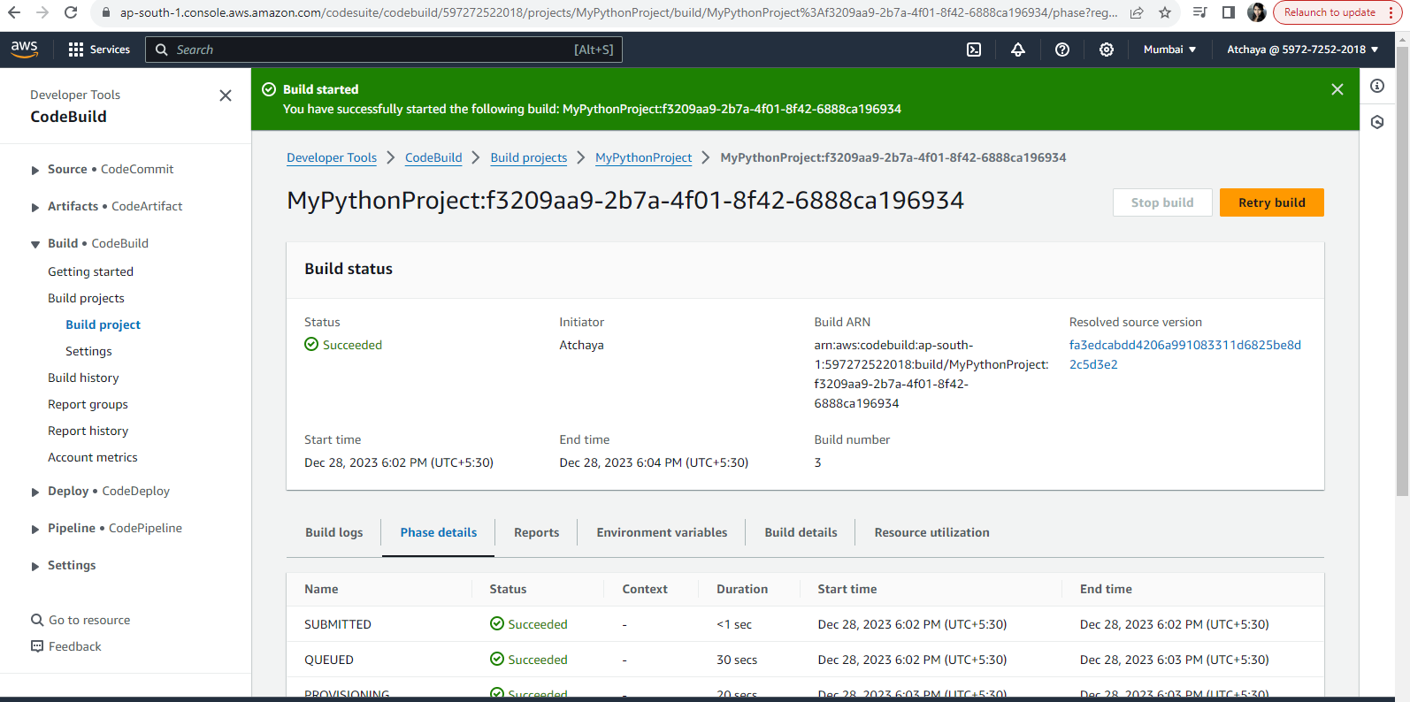

Code deploy

Deployment group created

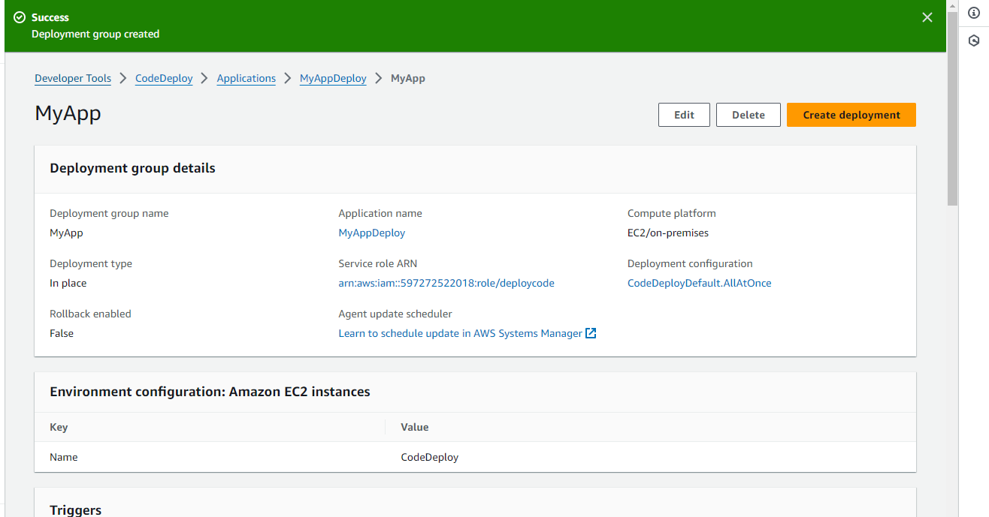

Deployment created and deployment successful

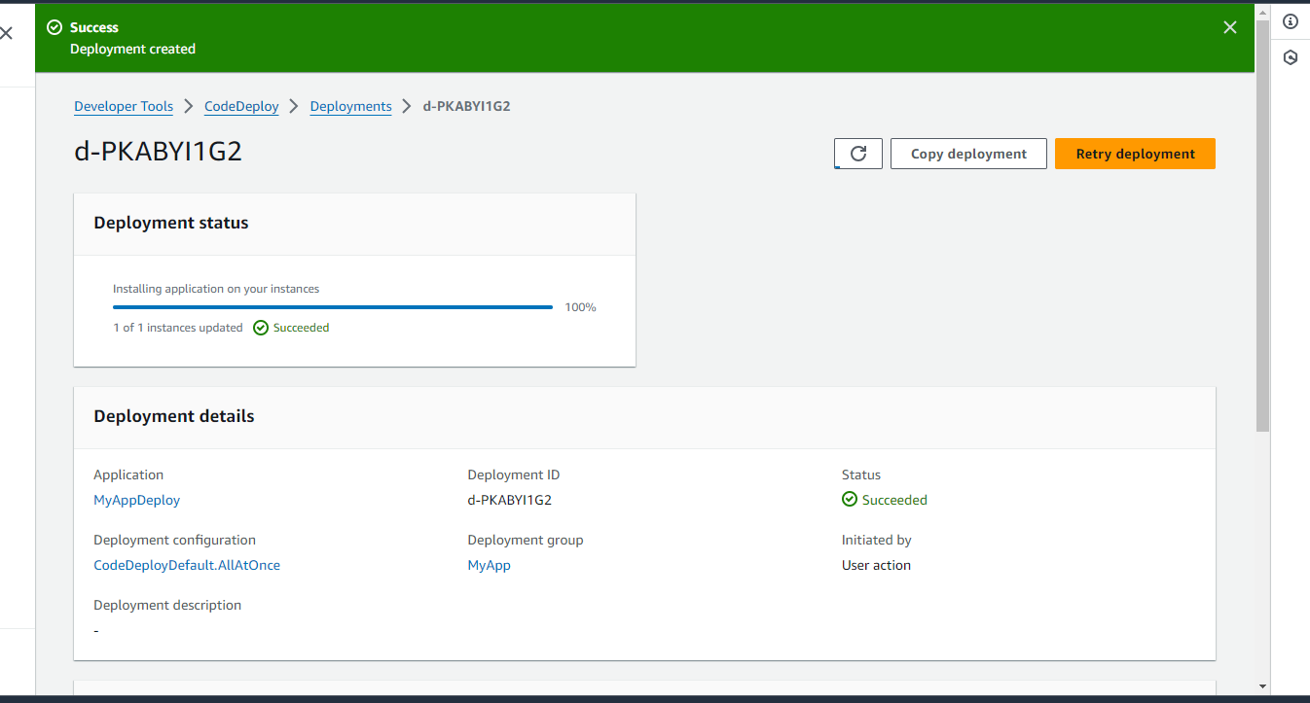

Docker image pushed to docker hub repo

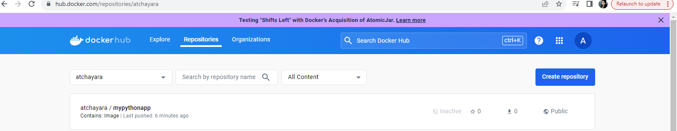

Code Pipeline

Pipeline created and deployed successfully

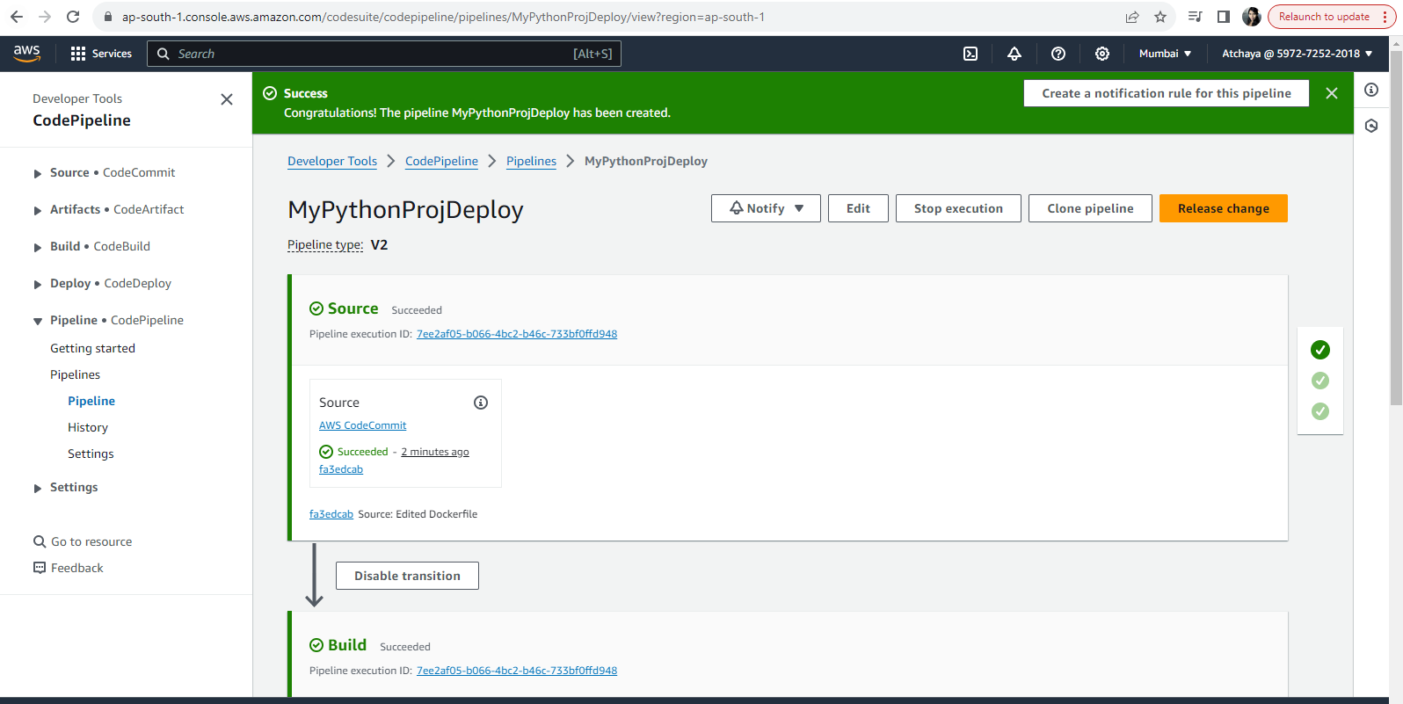

Docker image is pushed to docker hub repo

